./

GENESIS - Learning Outcome & MBSE Summary Report



|  |  |  |  |  |  |
| --- | --- | --- | --- | --- | --- |
| **Ver. Rel. No.** | **Release Date** | **Prepared. By** | **Reviewed By** | **To be Approved** | **Remarks/Revision Details** |
| 1 | 20/12/2020 | NAVEEN KUMAR PAPPURU |  |  |  |
|  |  |  |  |  |  |
|  |  |  |  |  |  |
|  |  |  |  |  |  |
|  |  |  |  |  |  |

**Details**

TABLE OF CONTENTS:

TABLE OF CONTENTS: 3

Certification 4

Mat lab onramp 4

Simulink Onramp 4

State flow Onramp 5

ACTIVITY 2 6

Subsystems 6

Power train 6

Chassis 7

Electronics 7

Steering 7

Suspension 7

Control Systems 8

Function 8

Power-assisted brakes 8

Disc brake 10

Drum brake 11

Activity 3 13

Infineon 13

Renesys 13

Atmel 14

MPXY8000 Series Tire Pressure Monitoring Sensor: AN1954/D 14

ECU (Electronic Control Unit) 14

Actuators: 14

Sensors: 15

Comparative analysis of Sensors: 15

Comparative analysis of Actuators: 16

Activity 4 16

How BMC is applicable to transport? 16

Activity 5 17

Requirements: 17

Low Level Requirements: 17

Inputs: 17

Outputs: 17

Scope: 17

Overall Logic: 18

Test Plan: 18

**Conclusion:** 19

**Challenges faced and how were they overcome** 19

# Certification

## Mat lab onramp



## Simulink Onramp



## State flow Onramp



# ACTIVITY 2

## Subsystems

* These include powertrain, chassis, electronics, steering, suspension, control systems, and composites. All of the subsystems are important and dependent on each other.
* Designers typically do not choose just one subsystem to work on, but divide their time based on the priority of the subsystem.

## Power train

* The powertrain subsystem includes everything that is responsible for transmitting its power to the wheels.
* The first component after the engine is the continuously variable transmission (CVT). The CVT provides a dual purpose in our vehicle. First, it acts as an automatic transmission, allowing adjustment to the final drive ratio
* It also functions as a clutch between the engine and transmission as its pulleys allow for slip at engine idle. After the CVT, power is transferred into a standard transmission, allowing gear ratios in forward and reverse.
* This is helpful for different parts of the competition or when our motion is hindered by an obstacle. Power is then transmitted to the differential, whose job is to directly power the left and right wheels while allowing them to rotate at different velocities around turns.
* Out of the differential, power goes to the rear wheels via a set of constant velocity (CV) joints and half shaft axles.

## Chassis

* The group which develops the chassis subsystem work alongside all the other subsystems to ensure that the strength and geometry of the chassis satisfies the requirements set by the Society of Automotive Engineers (SAE) for the competition, along with the design criteria established by the team. Fabrication of the frame begins during winter break.

## Electronics

* Electronics are implemented in the design, testing, and fabrication of the vehicle in many ways. Data acquisition through an assortment of sensors gives designers useful information about a variety of characteristics, including various angular velocities and accelerations, suspension travel, and component temperatures.
* This data is then utilized in the design process to create/modify parts or to verify and reinforce computer-simulated results through real-world testing.
* A driver-interface system has been used in the past to allow the driver to view live information about the vehicle through an LCD mounted in front of the steering wheel. In addition, all of the required lighting, alarms, and kill-switches are covered under this subsystem.

## Steering

* The steering subsystem is responsible for providing the operator with maximum directional control over the vehicle via the steering wheel. The steering wheel rotational input is transferred down the steering column to the steering rack.
* The purpose of the steering rack is to translate the rotational motion of the steering column into lateral, linear motion by means of a rack and pinion gear set. Attached on each side of the rack are tie rods, which transfer the lateral motion of the rack to the steering arms - one mounted at each front wheel.
* When the tie rods push / pull on the steering arms, there is a change in the direction of the wheel. The combined ratio of the gear set and steering arms provide the final steering ratio of the vehicle. In the end, if the driver turns the steering wheel clockwise, the car will turn right and when turned counterclockwise, the car will turn left.

## Suspension

* The Designing of the suspension requires a combination of numerical analysis, computer simulation, and real world testing. All other subsystems are vastly affected by suspension geometry, tire choice, and shock setting.
* Because nearly all suspension components are fabricated by the team, members will learn about the design, fabrication, data collection, and analysis techniques involved in the performance and handling of the vehicle to a considerable degree.

## Control Systems

* The control systems of the vehicle encompasses all driver-vehicle interfaces. Cockpit ergonomics are researched to ensure that the car is suitable for commuter conditions.
* Transmission and steering controls are laid out to ensure that the driver can quickly and comfortably control the vehicle without excessive effort.
* This group is also tasked with designing the brake system so that the car successfully locks all four wheels, a requirement for technical inspection. Any electronics on the vehicle are also included in the control systems category.

## Function

* The powertrain provides power to the car. Power is made by the engine, then transferred to the driveshaft through the transmission. The driveshaft, in a rear wheel drive car, turns the gears in the rear, which in turn turns the axles and finally, the wheels. The rear and the axles are also part of the drivetrain.
* Most cars now also have a load-sensitive pressure-limiting valve. It closes when heavy braking raises hydraulic pressure to a level that might cause the rear brakes to lock, and prevents any further movement of fluid to them.
* Advanced cars may even have complex anti-lock systems that sense in various ways how the car is decelerating and whether any wheels are locking. Such systems apply and release the brakes in rapid succession to stop them locking.

## Power-assisted brakes

* Many cars also have power assistance to reduce the effort needed to apply the brakes.

Usually the source of power is the pressure difference between the partial vacuum in the inlet manifold and the outside air.

* The servo unit that provides the assistance has a pipe connection to the inlet manifold.

[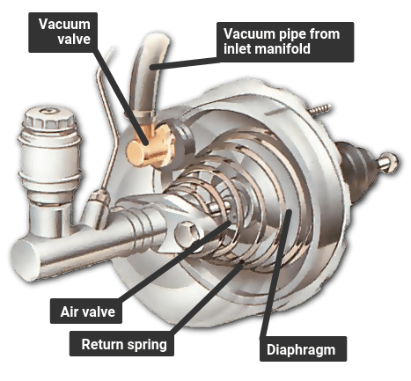](https://www.howacarworks.com/illustrations/servo-assisted-braking)

* A direct-acting servo is fitted between the brake pedal and the master cylinder. The pedal can work the master cylinder directly if the servo fails or if the engine is not running.
* A direct-acting servo is fitted between the brake pedal and the master cylinder. The brake pedal pushes a rod that in turn pushes the master-cylinder piston.
* But the brake pedal also works on a set of air valves, and there is a large rubber diaphragm connected to the master-cylinder piston.
* When the brakes are off, both sides of the diaphragm are exposed to the vacuum from the manifold. Pressing the brake pedal closes the valve linking the rear side of the diaphragm to the manifold, and opens a valve that lets in air from outside.
* The higher pressure of the outside air forces the diaphragm forward to push on the master-cylinder piston, and thereby assists the braking effort.
* If the pedal is then held, and pressed no further, the air valve admits no more air from outside, so the pressure on the brakes remains the same.
* When the pedal is released, the space behind the diaphragm is reopened to the manifold, so the pressure drops and the diaphragm falls back.
* If the vacuum fails because the engine stops, for example the brakes still work because there is a normal mechanical link between the pedal and the master cylinder. But much more force must be exerted on the brake pedal to apply them.

[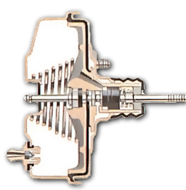](https://www.howacarworks.com/illustrations/how-the-brake-servo-works).

Brake off - both sides of the diaphragm are under vacuum

[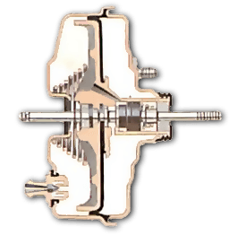](https://www.howacarworks.com/illustrations/how-the-brake-servo-works--2)

Applying the brake lets air in behind the diaphragm, forcing it against the cylinder.

## Disc brake

[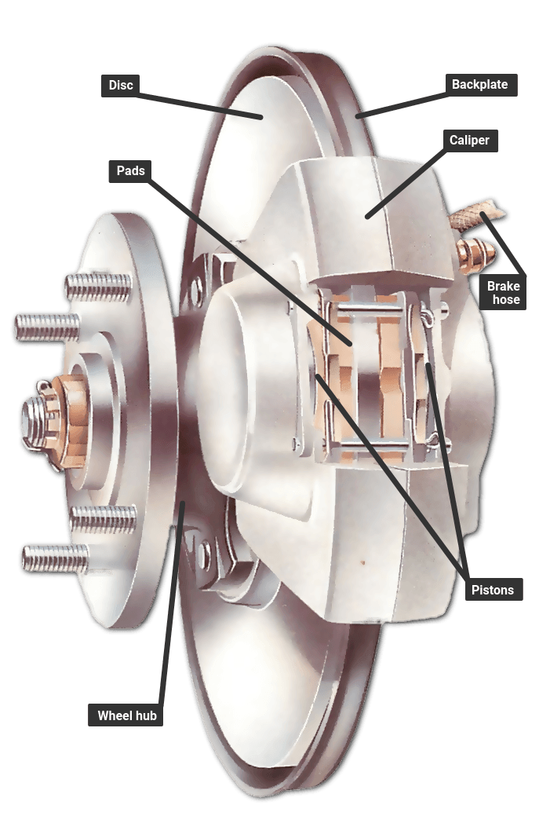](https://www.howacarworks.com/illustrations/disc-brake)

* The basic type of disc brake, with a single pair of pistons. There may be more than one pair, or a single piston operating both pads, like a scissor mechanism, through different types of calipers - a swinging or a sliding caliper.
* A disc brake has a disc that turns with the wheel. The disc is straddled by a caliper, in which there are small hydraulic pistons worked by pressure from the master cylinder.
* The pistons press on friction pads that clamp against the disc from each side to slow or stop it. The pads are shaped to cover a broad sector of the disc.
* There may be more than a single pair of pistons, especially in dual-circuit brakes.
* The pistons move only a tiny distance to apply the brakes, and the pads barely clear the disc when the brakes are released. They have no return springs.

[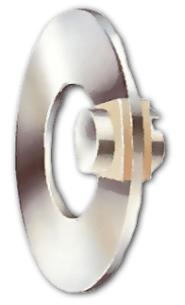](https://www.howacarworks.com/illustrations/disc-brakes--2)

* When the brake is applied, fluid pressure forces the pads against the disc. With the brake off, both pads barely clear the disc. Rubber sealing rings round the pistons are designed to let the pistons slip forward gradually as the pads wear down, so that the tiny gap remains constant and the brakes do not need adjustment.
* Many later cars have wear sensors leads embedded in the pads. When the pads are nearly worn out, the leads are exposed and short-circuited by the metal disc, illuminating a warning light on the instrument panel.

## Drum brake

[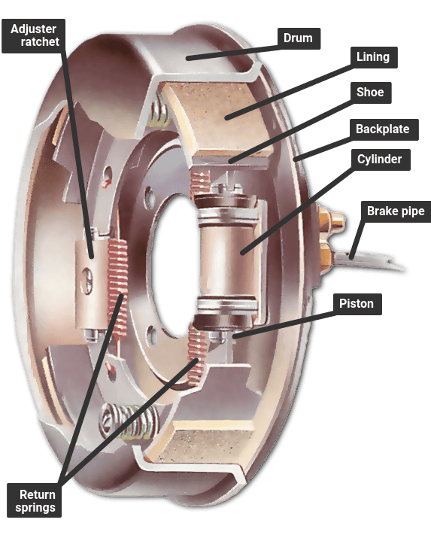](https://www.howacarworks.com/illustrations/drum-brake)

* A drum brake with a leading and a trailing shoe, which has only one hydraulic cylinder; brakes with two leading shoes have a cylinder for each shoe and are fitted to the front wheels on an all-drum system.
* A drum brake has a hollow drum that turns with the wheel. Its open back is covered by a stationary back plate on which there are two curved shoes carrying friction linings.
* The shoes are forced outwards by hydraulic pressure moving pistons in the brake's wheel cylinders, so pressing the linings against the inside of the drum to slow or stop it.

[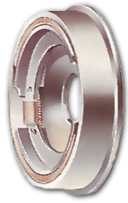](https://www.howacarworks.com/illustrations/drum-brakes)

* With the brakes on, the shoes are forced against the drums by their piston. Each brake shoe has a pivot at one end and a piston at the other. A leading shoe has the piston at the leading edge relative to the direction in which the drum turns.
* The rotation of the drum tends to pull the leading shoe firmly against it when it makes contact, improving the braking effect.
* Some drums have twin leading shoes, each with its own hydraulic cylinder; others have one leading and one trailing shoe - with the pivot at the front. This design allows the two shoes to be forced apart from each other by a single cylinder with a piston in each end.
* It is simpler but less powerful than the two-leading-shoe system, and is usually restricted to rear brakes. In either type, return springs pull the shoes back a short way when the brakes are released.
* Shoe travel is kept as short as possible by an adjuster. Older systems have manual adjusters that need to be turned from time to time as the friction linings wear. Later brakes have automatic adjustment by means of a ratchet.
* Drum brakes may fade if they are applied repeatedly within a short time - they heat up and lose their efficiency until they cool down again. Discs, with their more open construction, are much less prone to fading.

# Activity 3

## Infineon

The classical BCM combines all 5 core functionalities of an electronic control unit:

The number of body functions has increased, but also their variants of these functions required for different vehicle trim levels. For example; one module may support seat movement to bidirectional lift, slide, recline and adjust lumbar and headrests, as well as heating and cooling but this module, may only include some of these for a low-end vehicle.  This creates a need for flexibility and scalability of product families to create a BCM platform that can accommodate easy variants and changes throughout the design two years after SOP.

Infineon’s Power Switch families PROFET tm, SPOC tm, and SPIDER have the most scalable portfolio of protected switches in the market to enable this flexibility in hardware and software.

Reference:

<https://www.infineon.com/cms/en/applications/automotive/body-electronics-and-lighting/body-control-modules/?redirId=64463#:~:text=Sensing%20with%20pressure%20sensors%20of,AURIX%E2%84%A2%20Families%20of%20microcontroller>

YouTube link:

<https://youtu.be/s_d7FUq_4t8>

## Renesys

Electronic control units (ECUs) can now be found everywhere in automobiles, from power windows and airbags to lamps, mirrors, doors, and seats. Due to this trend, the burden on software development for ECUs has also increased. Renesas offers a wide variety of products for automotive body, including MCUs, SoCs, sensors and power management devices.

YouTube link:

[**https://youtu.be/sAL65FqeyMw**](https://youtu.be/sAL65FqeyMw)

## Atmel

### MPXY8000 Series Tire Pressure Monitoring Sensor: AN1954/D

* The MPXY8000 Series sensor is a fully integrated sensor targeted specifically for tire pressure monitoring systems (TPMS)
* Capacitive absolute pressure sensor with a range from 0 kpa to 637.5 kpa
* Temperature sensor capable of measuring temperature in the range of -40°C to 125°C
* Optimized for low-voltage and low-power draw suitable for powering with a single 3-volt lithium battery
* Media compatible with fluids and media and media that are commonly found within the tire environment
* Operates in four modes namely Standby/Reset (Idle), Measure Pressure, Measure Temperature and Output Read mode

## ECU (Electronic Control Unit)

Definition: An electronic control unit (ECU), also known as an electronic control module (ECM), is an [embedded system](https://en.wikipedia.org/wiki/Embedded_system) in [automotive electronics](https://en.wikipedia.org/wiki/Automotive_electronics) that controls one or more of the [electrical systems](https://en.wikipedia.org/wiki/Automotive_electronics#Types) or subsystems in a vehicle.

Applications:

* Precision, integrative control functions keep diesel engineemissions clean. ...
* Reduces collision damage to large vehicles. ...
* Automatic shifting like that of automatic transmission. ...
* Enhances fuel efficiency and environmental performance. ...
* Enhances vibration absorption performance and loading/unloading efficiency.

Reference:

<https://www.pistonheads.com/features/ph-features/what-is-an-electronic-control-unit-ph-explains/37771>

<https://en.wikipedia.org/wiki/Electronic_control_unit>

## Actuators:

* **Control Relay:** Relay that provides supply power to engine ECU and various actuators and fuel pump relay that drives fuel pump.
* **Fuel Pump:** Gives the fuel at the right pressure suitable for its work.
* **Injector:** It is an injection nozzle with soleniod that is controlled by ECM. Using intake air quantity and engine rpm, ECM calculates basic fuel injection time, and calculates corrective fuel
* **Injector:** Injection period time on the basis of engine coolant temp, feedback signal from oxygen sensor during closed-loop-control
* **ISA (Idle Speed Actuator):** It is installed at throttle body of engine and control air intake rate into engine depending on ECU signal.
* **Spark plugs:** This transmit electrical energy that turns fuel into working energy
* **The Ignition coil:** This functions as an energy-storage device and transformer. It is supplied with DC voltage from the alternator, and provides the high tension ignition pulses for the spark plugs.

Reference:

<http://www.micro-tronik.com/learning/technical-information/automotive/repair-basics/actuators/>

## Sensors:

1. **Temperature Sensors**/Detectors/Transducers are electronic devices that detect thermal parameters and provide signals to the inputs of control and display devices.

2. **Proximity Sensors** are electronic devices used to detect the presence of nearby objects through non-contacting means.

3. **Pressure Sensors**/Detectors/Transducers are electro-mechanical devices that detect forces per unit area in gases or liquids and provide signals to the inputs of control and display devices.

4. **Position Sensors**/Detectors/Transducers are electronic devices used to sense the positions of valves, doors, throttles, etc. and supply signals to the inputs of control or display devices.

5. **Photoelectric sensors** are electrical devices that sense objects passing within their field of detection, although they are also capable of detecting color, cleanliness, and location if needed.

6. **Motion Sensors**/Detectors/Transducers are electronic devices that can sense the movement or stoppage of parts, people, etc. and supply signals to the inputs of control or display devices.

7. **Level Sensors**/Detectors are electronic or electro-mechanical devices used for determining the height of gases, liquids, or solids in tanks or bins and providing signals to the inputs of control or display devices.

Reference:

<https://www.thomasnet.com/articles/instruments-controls/sensors/>

## Comparative analysis of Sensors:

|  |  |  |
| --- | --- | --- |
| **Parameters** | **RTD (Resistive Temperature Detectors)** | **Thermocouple** |
| **Temperature range** | -200°C to 850°C | -100°C to 325°C |
| **Accuracy** | Best(0.1°C - 1°C) | Good(0.05°C - 1.5°C) |
| **Linearity** | Linear | Exponential |
| **Sensitivity** | 0.00385 ohm/ohm/°C (Platinum) | 10s of micro v /°C |
| **Response Time** | Slow(1s - 50s) | Fast(0.1s - 5s) |
| **Long Term Stability** | Best | Good |
| **Circuitry** | Complex | Simple to complex |
| **Typical size** | Bead diameter= 5 x wire diameter | 0.25 x 0.25 in |
|  |  |  |

## Comparative analysis of Actuators:

|  |  |  |
| --- | --- | --- |
| **Parameters** | L298 | L293x |
| **Voltage range** | +5 to +46V | 4.5 V to 36 V |
| **Storage and Junction Temperature** | –40 to 150 | 65 150 |
| **protection** | Internal ESD protection | Over temperature |
| **Maximum Peak motor current:** | 1.2A | 3A |
| **Application** | * Automatic door control systems. * CNC machines | * Stepper Motor Drivers * DC Motor Drivers |

# Activity 4

## How BMC is applicable to transport?

The rapidly increasing demand for driving comfort and safety inevitably leads to the need for cutting-edge vehicle electrical system architecture. A comprehensive body control module system is aimed at communicating and integrating the work of all electronic modules through the vehicle bus. Strictly speaking, a BCM is an embedded system that controls load drivers and coordinates activation of auto electronics units.

The microcontrollers and connectors integrated into a BCM constitute the central structural unit of the system responsible for the controlling part. Operating data is transmitted to the control module through input devices. These may include sensors, vehicle performance indicators, and variable reactors.

After data is processed by the module, a response signal is generated through integrated output devices, including relays and solenoids. Through the system of output devices, the BCM coordinates the work of various electronics systems. This diagram of a body control module design shows a customized circuit that works as a gateway connecting and integrating smaller circuits.

# Activity 5

**Development of Power Mirror subsystem of a car:**

## Requirements:

## Low Level Requirements:

* When Car is in ON mode, the system is enabled. Based on the input given to the system the position mirrors get changed.
* When input given to system is 1, then the position of mirror gets tilt up side.
* When input given to system is -1, then the position of mirror gets tilt down side.
* When input given to system is 2, then the position of mirror gets pan right side.
* When input given to system is -2, then the position of mirror gets pan left side.
* When Car is in OFF mode, the system is disabled. The position of car mirrors remains same.

## Inputs:

* Car_in_on-mode: 1
* Car_in_off_mode: 0
* Input_for_tilt_pan: 1 or -1 or 2 or -2

## Outputs:

## Scope:

* Displays 1 for tilt up
* Displays -1 for tilt down
* Displays 2 for pan right
* Displays -2 for pan left

## Overall Logic:

* Constant blocks are used for providing input to either for enable port of subsystem through manual switch or to the input port of subsystem.
* Manual switch block is used to switch based on the car mode.
* Scope is used to display the position of mirrors based on the input provided.
* Enabled subsystem is used to implement logic for the change of mirror position.
* If block is used to set the conditions for different mirror positions.
* Ramp signal blocks are used to provide input to the action block.
* Action subsystems are used to provide the valid output to the scope based on the condition provided by if block and the ramp signal block.

## Test Plan:

|  |  |  |  |  |
| --- | --- | --- | --- | --- |
| **Sl No** | **Condition** | **Input** | **Expected Output** | **Actual Output** |
| TP_01 | Enable pin is on | Provide 1 for Input_for_tilt_pan | Displays 1 on scope window | Displays 1 on scope window |
| TP_02 | Enable pin is on | Provide -1 for Input_for_tilt_pan | Displays -1 on scope window | Displays -1 on scope window |
| TP_03 | Enable pin is on | Provide 2 for Input_for_tilt_pan | Displays 2 on scope window | Displays 2 on scope window |
| TP_04 | Enable pin is on | Provide -2 for Input_for_tilt_pan | Displays -2 on scope window | Displays -2 on scope window |
| TP_05 | Enable pin is off | Provide 1 for Input_for_tilt_pan | Displays 0 on scope window | Displays 0 on scope window |
| TP_06 | Enable pin is off | Provide -1 for Input_for_tilt_pan | Displays 0 on scope window | Displays 0 on scope window |
| TP_07 | Enable pin is off | Provide 2 for Input_for_tilt_pan | Displays 0 on scope window | Displays 0 on scope window |
| TP_08 | Enable pin is off | Provide -2 for Input_for_tilt_pan | Displays 0 on scope window | Displays 0 on scope window |

## **Conclusion:**

Developed a subsystem of power mirrors of car using the MATLAB and SIMULINK which automatically controls the mirror using a switch and providing inputs based on the user needs.

## **Challenges faced and how were they overcome**

As new to the Simulink, initially faced problems to develop a system with help of library browser. Based on the input given by GEA team and Colleagues helped us a lot to overcome this problem and finally developed a system successfully.